### DRAFT

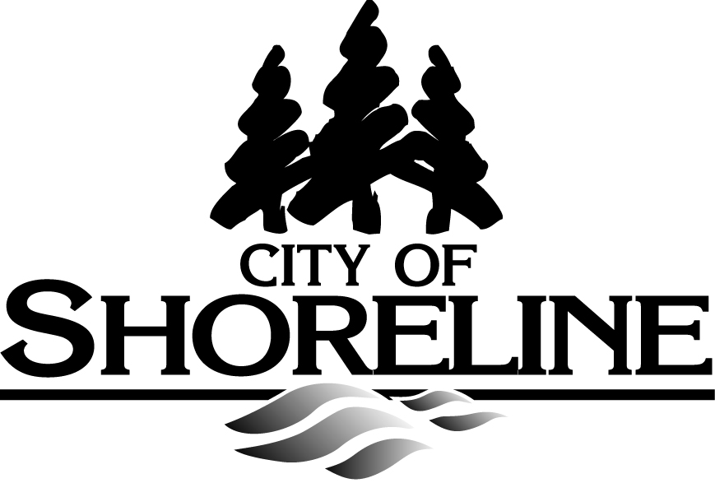

### Council of Neighborhoods

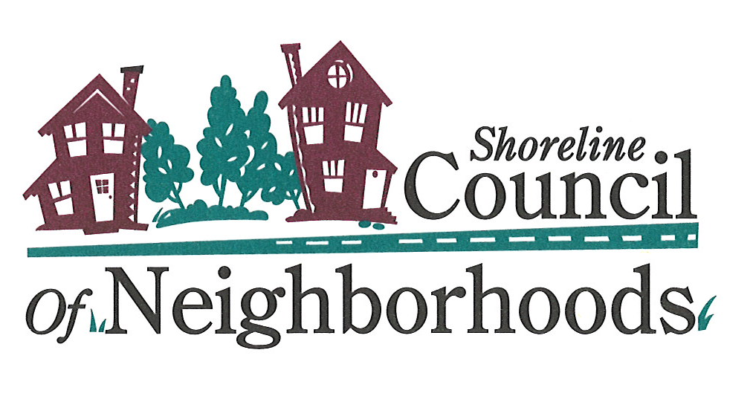

### Agenda

### Wednesday, June 2, 2010

**7:00 – 9:00 p.m.**

***Shoreline City Hall, Council Chambers***

# *Social Time* *please feel free to come early and network* 6:30 – 7:00 PM

# Call to Order and Roll Call                                                        7:00 – 7:05 PM

*Arthur Peach, Chair*

**II. Public Comment**(5 minutes each person; add time if necessary) **7:05 – 7:10 PM**

# III. Block Party and National Night Out 7:10 – 7:35

**Right-of-Way Permit Process**

*Jeff Forry, Permit Services Manager, City of Shoreline*

**IV. Summer Planning for Council of Neighborhoods Events 7:35 – 7:50**

* Swingin’ Summer Eve Book Sale - Wednesday, July 21
* Celebrate Shoreline Tent – Saturday, August 21
* Neighborhood Leaders Potluck

**BREAK    8:00 – 8:10 PM**

**V. Neighborhood Coordinator Report 8:10 – 8:15 PM** *Nora Smith, Neighborhood Coordinator*

**V.    Neighborhood Reports 8:15 – 8:45 PM**

**VI. Other Business 8:45 – 9:00 PM**

**VII. Adjourn**

**Parking** available on both floors of new parking garage behind City Hall; and on Midvale Avenue North.

**Want to submit an agenda item?**

**To submit an agenda item for the Council of Neighborhoods monthly meeting:**

1. Request that the item be added to the next meeting’s agenda during the Council of Neighborhoods meeting; or
2. Contact any Board member or Neighborhood Coordinator (Nora Smith) at least two weeks prior to the next Council of Neighborhoods meeting date to request the agenda item; or
3. Attend a Board meeting to request the agenda item. Board meetings are generally scheduled two weeks before the Council of Neighborhoods meeting. Call a Board member or staff to confirm meeting time and place; or
4. Request an agenda item be added at the start of the Council of Neighborhoods meeting (during the approval of the agenda). This is the least preferred method and subject to the prerogative of the Chair.

