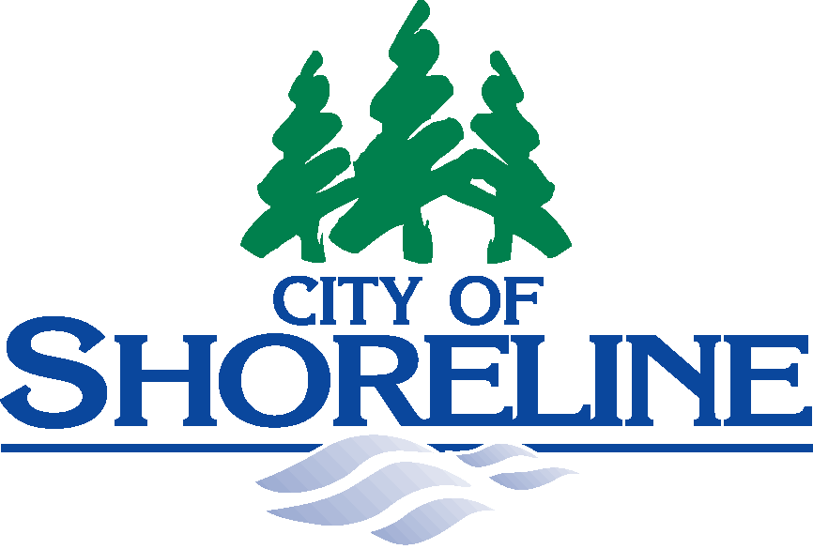 |  | Shoreline City Hall  17500 Midvale Avenue North  Shoreline, Washington 98133  (206) 801-2230
PRCS/Tree Board
SPECIAL MEETINGS NOTICE
PRCS/Tree Board Attendance at
Training for Advancing Racial Equity

As required by RCW 42.30, the Open Public Meetings Act, you are hereby notified of the following PRCS/Tree Board Special Meeting:
Session One – Beginning Conversations About Race
Wednesday, October 21, 2020 from 7:00-8:30 p.m.
Attend via Zoom: | https://zoom.us/j/91451105572?pwd=T1JIZUlWZnlwQXE3ZHdKMTRLbENSZz09
Join via Phone: | 253-215-8782  Meeting ID: 914 5110 5572 Passcode: 676369

Parks, Recreation, and Cultural Services/Tree Board, along with members of City Council and the Planning Commission will attend a 3-part racial equity training. Content will include the history of race; implicit and explicit bias; definitions of individual, institutional, and structural racism; and discussion of the impacts and ways to take action. Training sessions may include short exercises in breakout rooms that are not open to the public.
Session One – 10/21/20, 7:00-8:30 p.m.  Beginning Conversations About Race  - Assumptions and Values  - Role of Government and Racial Equity | Session Two – TBD  Shared Language and Implicit Bias  - Equity versus Equality  - Implicit Bias  - Strategies to address bias
Session Three – TBD
Putting Ideas into Action
- Institutional Bias
- Types of Racism
- Opportunities for Change

Dated this 19th Day of October, 2020.

Marth Karl, RCCS- Admin II
