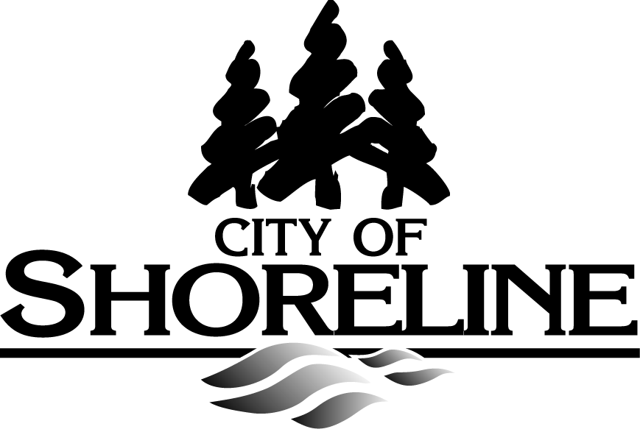

**Environmental Mini-Grant**

**Application**

**Application Directions:** Applications must be limited to 5 pages total in 10-point type size. Please be clear, succinct, and number all pages. Please contact Autumn Salamack, Environmental Services Coordinator, at 206-801-2452 with questions regarding project eligibility prior to submitting your application.

**Date Application Submitted**:

|  |  |
| --- | --- |
| **Project Title** |  |
| **Organization/School Name** |  |
| Address |  |
| Website |  |
| Telephone |  |
| **Project Coordinator’s Name** |  |
| Project Coordinator’s Telephone |  |
| Project Coordinator’s Email |  |

1. **Does your project address any of the following priority areas of focus?**

Work Towards a Zero Waste Shoreline

Support Reduction of Greenhouse Gas Emissions

Protect Our Natural Environment

1. **Briefly describe your project and how it aligns with one or more of the priority areas above.**
2. **What is the goal of the project and the environmental need identified?**
3. **Where will the project be conducted?** Please provide the address and indicate if the project will take place on public or private property.

Address:

Public property Private property

1. **If the project is on private property, what is the project’s measurable benefit to the public?**
2. **Project start date:**  **Project end date:**
3. **Project work plan:** *Briefly describe each project activity and when it will occur.*

|  |  |
| --- | --- |
| **Activity** | **Projected Date of Completion** |
|  |  |
|  |  |
|  |  |
|  |  |
|  |  |
|  |  |
|  |  |

1. **Are permits or letters of permission required for this project? If so, please list and attach.**
2. **Will this project take place in City of Shoreline Parks? If so, have you received approval for this project from the Parks Board? UPDATED 2/10/20: Projects in parks need approval from the Parks Department, not the Parks Board. If a project takes place in a City park, please confirm approval in the text portion of your application below.**
3. **Anticipated Project Items and Budget**

*Please include* ***ALL*** *anticipated project costs – not just project costs for which you are requesting grant funding. Attach any quotes for items or services, including hourly rates.*

|  |  |  |
| --- | --- | --- |
| **Item / Services** | **Source / Vendor** | **Estimated cost / Hourly rate** |
|  |  |  |
|  |  |  |
|  |  |  |
|  |  |  |
|  |  |  |
|  |  |  |
|  |  |  |

1. **Amount of funding requested from Environmental Mini-Grant Program:**

*Note: The City cannot pay in advance for goods and/or services. Recipients must submit an invoice for reimbursement of approved expenses, as documented in the grant agreement.*

*Note: If a vendor does not include tax on materials and supplies, the City will need to pay the tax and will deduct it from the grant amount funded.”*

1. **Project Match: Indicate how you will arrive at your 20% match for this project (e.g. labor, materials, or money) during the grant period.**

*The value of one general volunteer hour is $31.72. Professional services that are donated are valued at the ‘reasonable and customary rate’ for that service. Justification for a specific professional rate must be provided by the applicant and approved by the City before the service is utilized in the project.*

|  |  |
| --- | --- |
| **Match Item** | **Estimated Value** |
| *example: Volunteer labor 60 hours X $31.72/hr* | *$1,903.20* |
|  |  |
|  |  |
|  |  |
|  |  |
|  |  |
|  |  |
| **Estimated Total Value of Match:** |  |

1. **If you will be using volunteers for non-technical services, please describe how you will secure their participation in the project.**
2. **Does your project feature an active partnership with a Shoreline community organization (such as schools, neighborhood associations, or businesses)?** **If yes, please indicate the community organization with which you will partner and their role in the project.**
3. **Will your project require on-going maintenance or repair? If so, how will it be provided? If the project involves plantings on City property, please provide a plant list, site map and 3-year maintenance and watering plan.**

*Note: If the Mini-Grant project has been installed on private property, or on property owned by another public entity, such as the School District, King County, or Seattle City Light, the applicant will need to work with the property owner to develop and implement a maintenance plan.*

1. **Has your organization previously received funding from the Environmental Mini-Grant program?**
2. **Has the proposed project previously received funding from the Environmental Mini-Grant program?**

**Signed by Person Authorized to Sign Agreement between the City & Organization**

Print Applicant Name Applicant Signature Date

**(in blue ink)**

SIGNATURE LINE FOR SCHOOL PROJECTS

**Signed by Project Coordinator**

Print Name Signature Date

**(in blue ink)**

**Signed by School Principal**

Print Name Signature Date

**(in blue ink)**

**Application due:** No later than March 6, 2020

**Submit Un-signed Application to:** [asalamack@shorelinewa.gov](mailto:asalamack@shorelinewa.gov)

**Submit Signed Application to:** Environmental Services Coordinator

City of Shoreline

17500 Midvale Ave. N.

Shoreline, WA 98133