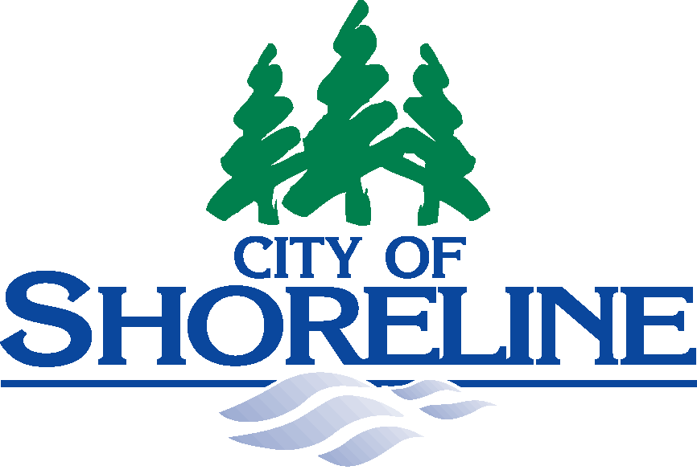 |  | 17500 Midvale Avenue North  Shoreline, Washington 98133-4921

PLANNING COMMISSION MEETING
CANCELLATION NOTICE

As required by RCW 42.30, the Open Public Meetings Act, you are hereby notified that the following meeting of the Shoreline Planning Commission has been CANCELLED:

Meeting Cancelled: | Thursday, May 4, 2017  7:00 p.m.  Regular Meeting
Next Meeting: | Thursday, May 18, 2017  7:00 p.m.  Regular Meeting - Joint Meeting with the Parks, Recreation and Cultural Services/Tree Board

Thank you,

Carla Hoekzema
Planning Commission Clerk
City of Shoreline

