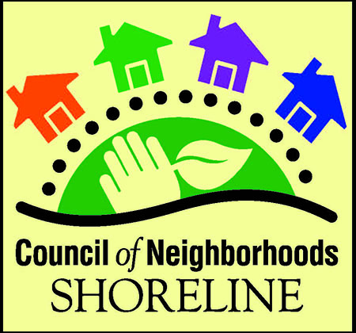

**Council of Neighborhoods**

**AGENDA**

**Wednesday, November 2, 2016**

**6:30 – 9:00 pm**

**Shoreline City Hall, Council Chambers**

**I*. Social Time – Come socialize and share* 6:30 – 7:00 pm**

**Light snacks available**

**II. Call to Order and Poem 7:00– 7:05 pm**

*Pete Gerhard, Chair*

We read a poem to bring our attention to the task before us, to focus our thoughts, and to provide a point of beginning to our evening.

Each neighborhood representative introduces themselves.

**III. Review November 2 agenda and October 5 minutes 7:05 – 7:08 pm**

**IV. Public Comment** (5 minutes each person; add time as needed)**7:08 – 7:13 pm**

**V. Visiting Councilmember Update 7:13 – 7:33 pm**

Mayor Chris Roberts provides an update on key issues before the City Council.

**VI. Budget 7:33 - 8 pm**

Administrative Services Director Sara Lane gives an overview of the 2017 budget.

**BREAK 8:00 - 8:10 pm**

**VII. Leader Interaction 8:10 – 8:45 pm**

Sheri Ashleman, Executive Director of Richmond Beach Community Association, shares information about recruiting, managing, and retaining volunteers.

**VIII. Board Report 8:45 – 8:50 pm**

**IX. Neighborhood Coordinator Report 8:50-8:55 pm**

**X. Announcements 8:55 pm**

**XI. Adjourn 9:00 pm**

**To submit an agenda item for the Council of Neighborhoods monthly meeting:** Make a request at a meeting or contact the Board Chair or Neighborhood Coordinator.