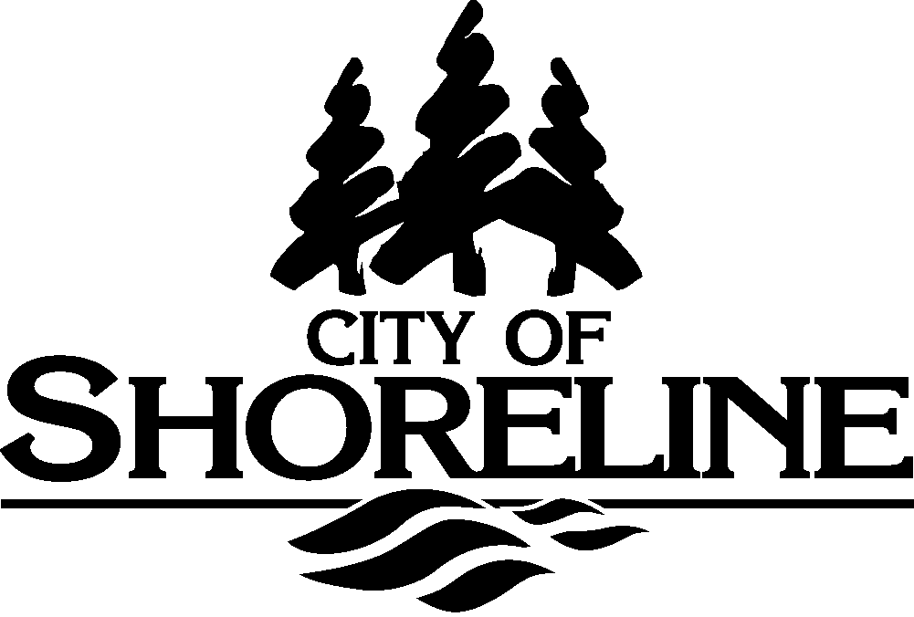

REQUEST FOR SEPA COMMENTS

# NAME OF PROJECT: **The City’s Public Works Department is preparing to apply to the Washington State Department of Fish and Wildlife for a Hydraulic Project Application for its five year operation and maintenance of surface water control devices. Typical actions covered will include trimming of vegetation, cleaning of trash racks, and removal of accumulated sediments.**

SITE ADDRESS: **Non-project action applies citywide.**

Routed to the agencies on **January 13, 2016**

The SEPA Checklist for this project can be located at:

<http://shorelinewa.gov/home/showdocument?id=24929>

If you have any questions, please contact: **Steven Szafran, AICP, Senior Planner, Planning & Community Development, City of Shoreline, at (206) 801-2512, OR e-mail:** sszafran@shorelinewa.gov

**Return your comments to:**

**City of Shoreline**

**Steven Szafran**

**17500 Midvale Avenue N**

**Shoreline, WA 98133-4905**

Comments are due by: **5:00 pm January 29, 2016**

______________________________________________________________________________

## FOR USE BY AGENCY RESPONDING TO REQUEST FOR SEPA COMMENTS

□ No Comment □ Comments Below or Attached

Agency: _______________________________________________________

Prepared by: __________________________________ Date: _________________

Title: _________________________________________________ Phone: ________________

Agency Comments: